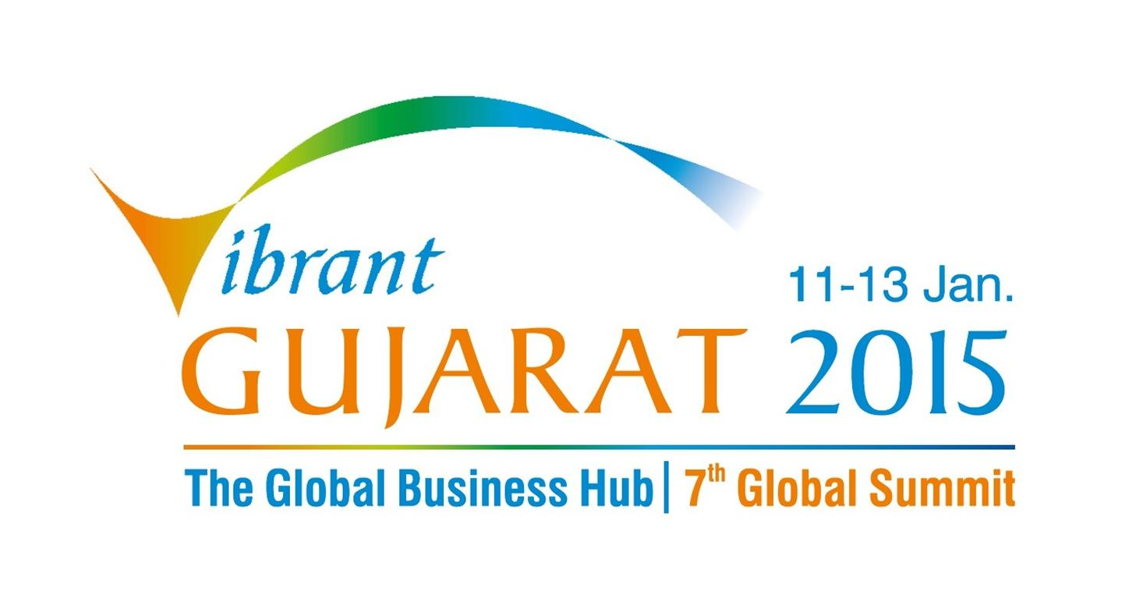




Seminar on Investment Opportunities in Gujarat
September 8, 2014: Renaissance Harbour View Hotel, Hong Kong

Tentative Programme

1000-1030 Hrs | Registration
1030-1040 hrs | Welcome and Introductory Remarks &  Introduction of the Delegation Members | CII / MoU Partner, Association
1040-1055 hrs | Special Address | Mr Prashant Agrawal  Consul General of India to Hong Kong
1055-1105 hrs | Video on Investment Opportunities in Gujarat – Vibrant Gujarat 2015
1105-1125 hrs | Special Address & Presentation on “Doing Business in Gujarat and the Investment Opportunities” | Mr L Chuaungo, IAS  Principal Secretary – Expenditure  Finance Department  Government of Gujarat
1125-1140 hrs | Presentation on Gujarat Tourism / Manufacturing Sector | Mr Sanjay Kaul, IAS  Managing Director  Gujarat Tourism Corporation Ltd.  Government of Gujarat
1140-1155 hrs | Presentation on the Gujarat Infrastructure Sector – Ports, Logistics, Renewable Energy, Water & Real Estate | Mr Prakash Gaur  Vice President  Gujarat International Finance  Tec-City Company Ltd.
1155-1225 hrs | Question and Answers (Interaction)
1225-1230 hrs | Vote of Thanks | CII
1230-1400 hrs | Networking Lunch  followed by B2B Meetings

